KELCO INDUSTRIES
WORK ORDER AND ASSEMBLY BUILD,
WIP AND ROUTING
(PROCESS FLOW DOCUMENTATION)

Role: Sales Manager
Creating Sales Order
Navigation: Transactions → Sales→ Enter Sales Orders
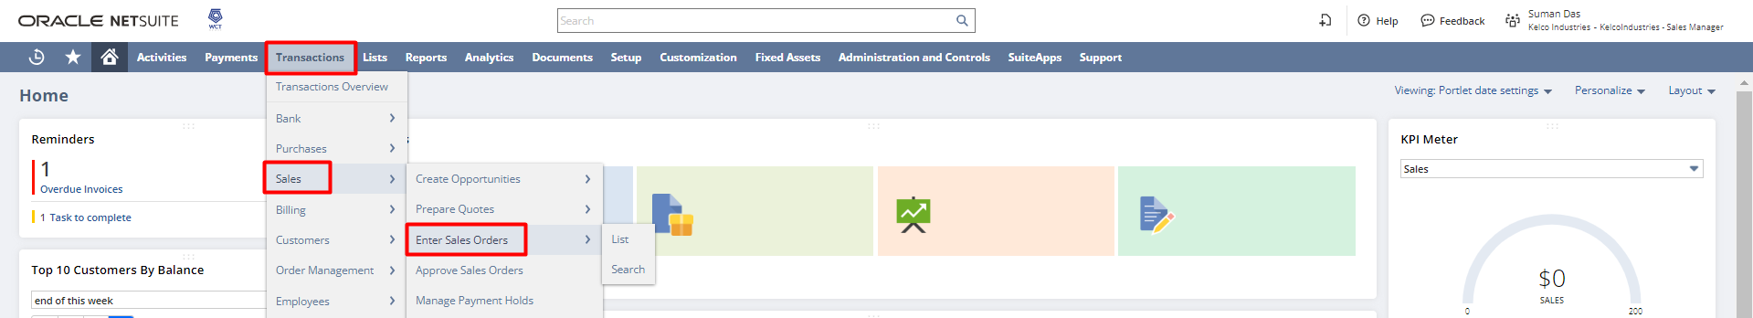

Enter the following details in the sales order form as mentioned below :
- Customer: Enter the customer name for which the sales order will be created.
- Location: Enter the location, where the item will be shipped.
- PO#: If your customer is paying by check, enter the number here. If your customer is issuing a purchase order, enter the PO number here.
- Sales Rep: If any sales rep is involved in the sales process then the name could be selected.
- Under the item subtab:
- Create WO: Check the checkbox if the item needs to be manufactured before shipping. In our upcoming example, we will be checking this checkbox to incorporate the special work order section.
- Item: Enter the items for which the customer has put forward an order.
- Quantity: Enter the number of items needed to be manufactured/shipped.
- Price Level: If the price of any item is defined in the item master the in the sales order it will be auto-populated but in case it is needed to provide any custom price or alternate price by toggling the price level field it can to edited.
- Rate & Amount: If the custom price option is selected then the custom price has to be set in the rate field and as the rate field is set the amount gets auto-calculated and populated.

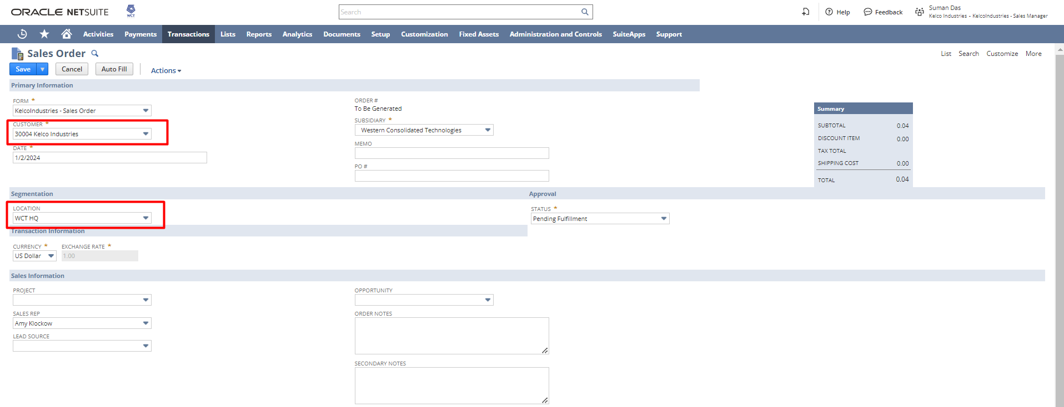
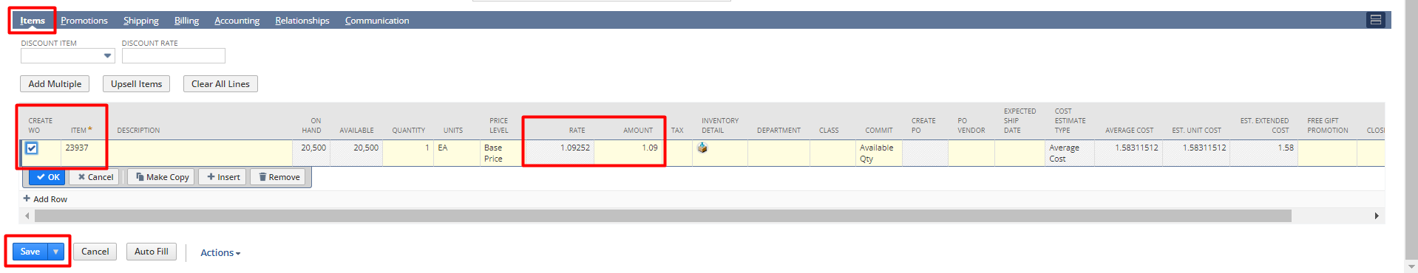
As all the details are filled out now save the sales order by clicking the Save button.

To view the sales order, click on the SO15 hyperlink.
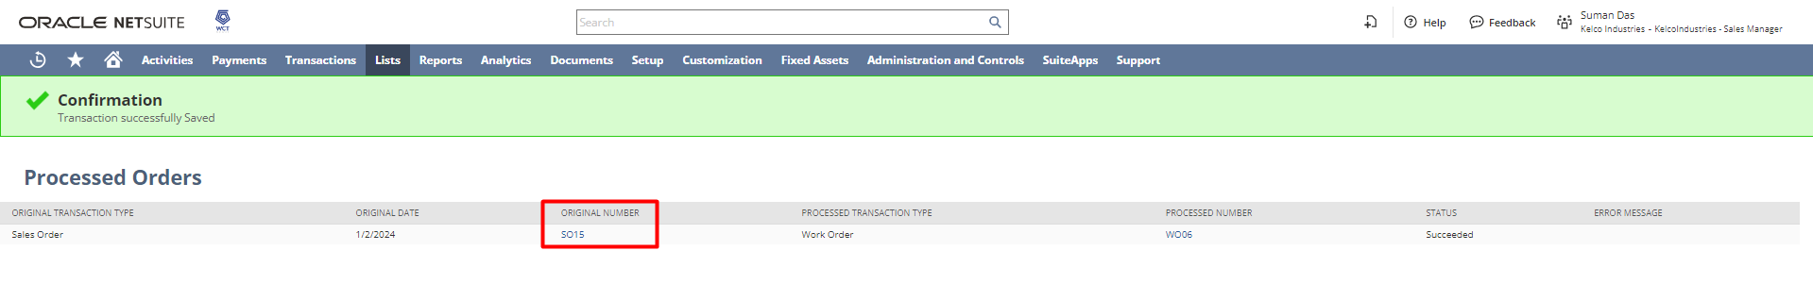
As the sales order gets saved a work order gets created. For this sales order, WO06 got created as a result. It was created because the Create WO checkbox was checked for this sales order.
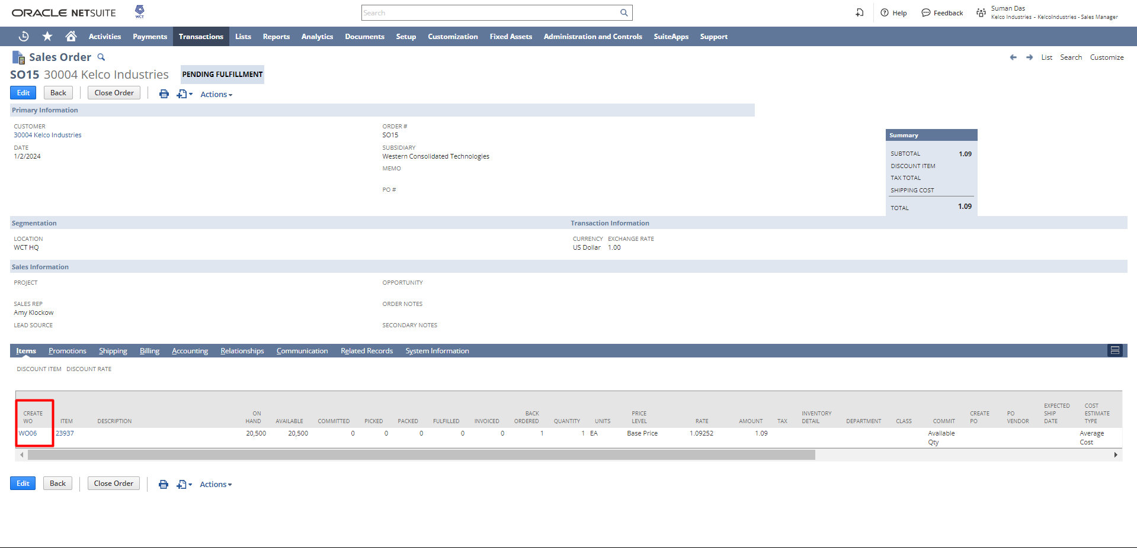

Now, we will be switching to the production manager role as the work order-related tasks come under the production manager role according to the standard practice in NetSuite.
Role: Production Manager
Viewing Work Order created from Sales Order
Navigation: Transaction → Manufacturing → Enter Work Orders → List
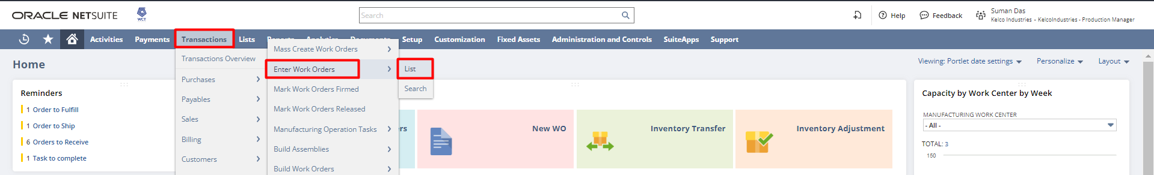
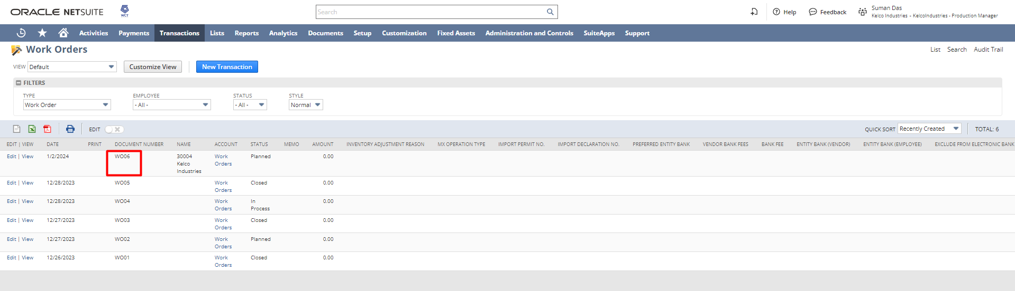
This is the work order created from the sales order. This can be tracked by observing the Created From field. In this example, it indicates that the work order has been created from SO15.
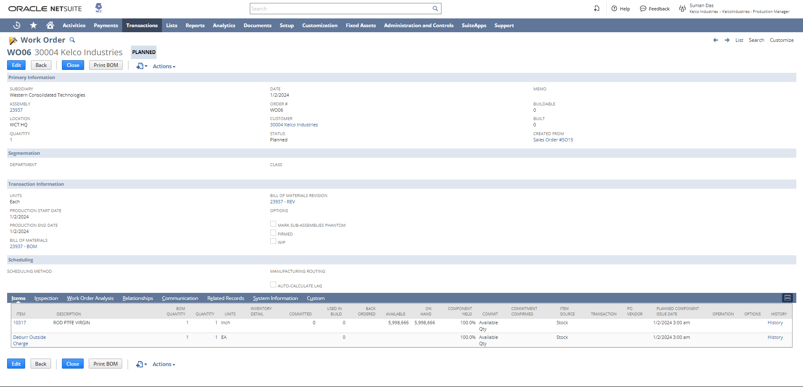

Printing BOM from Work Order
By clicking on the Print BOM button from the work order level, the associated BOM for this work order can be printed.
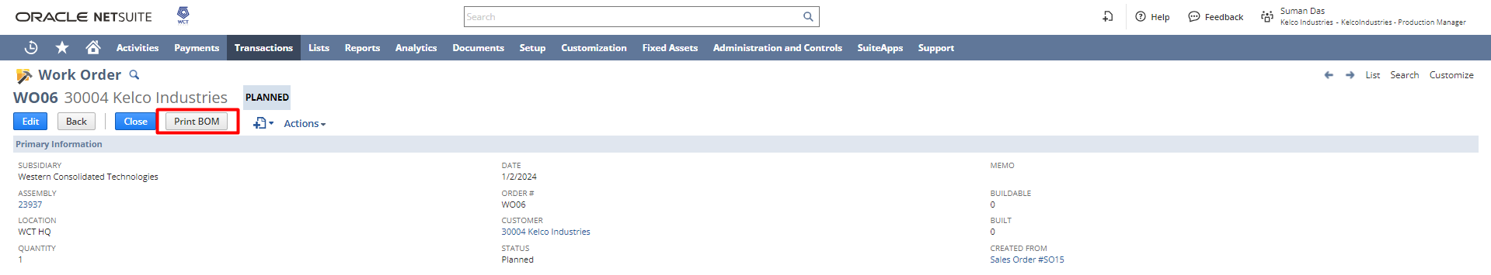
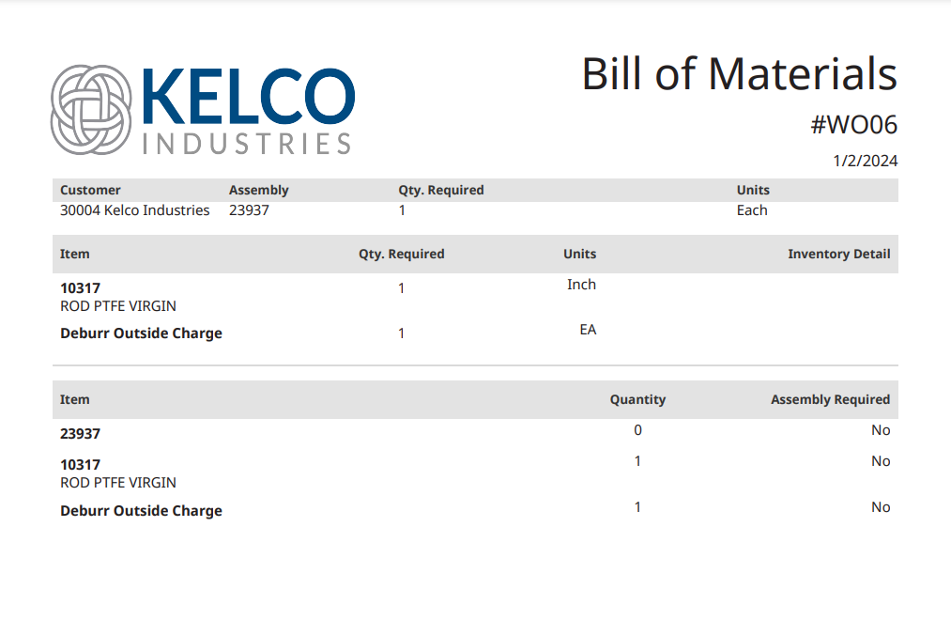
Use of Manufacturing Work in Process (WIP) checkbox
Manufacturers often use work orders to assemble the materials needed to produce an item. Manufacturing Work in Process lets manufacturers track work orders through the production process, from gathering materials, through shop floor assembly, to stocking finished goods.

Assembly items built using Manufacturing Work in Process (WIP) are divided into the following processes:
- Work Order Issue – Issue components to track material consumption or log service against a work order.
- Work Order Completion – Identify the quantity completed and stocked.
- Work Order Close – Generate reconciliation entries to post variances that may occur during the manufacturing process.

Note: To use the Issue components and Enter completion feature in the work order the WIP check box has to be checked and the work order should be in the Release status.
The process to Enable the Issue Components & Enter Completion Button
Edit the work order created and change the status to Released. Click Save.
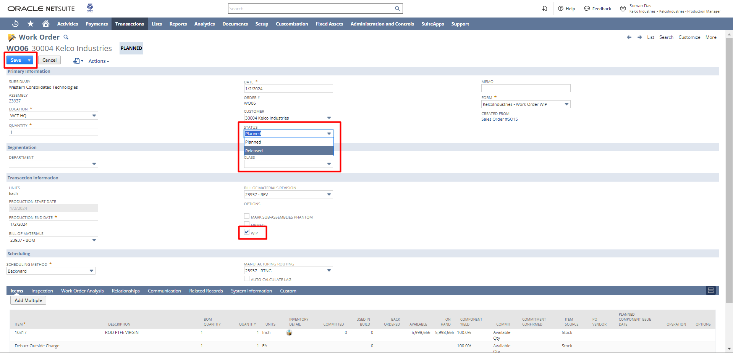
As the status was changed to released and the WIP checkbox was checked so as we saved the work order the Issue Components and Enter Completion button got popped up.
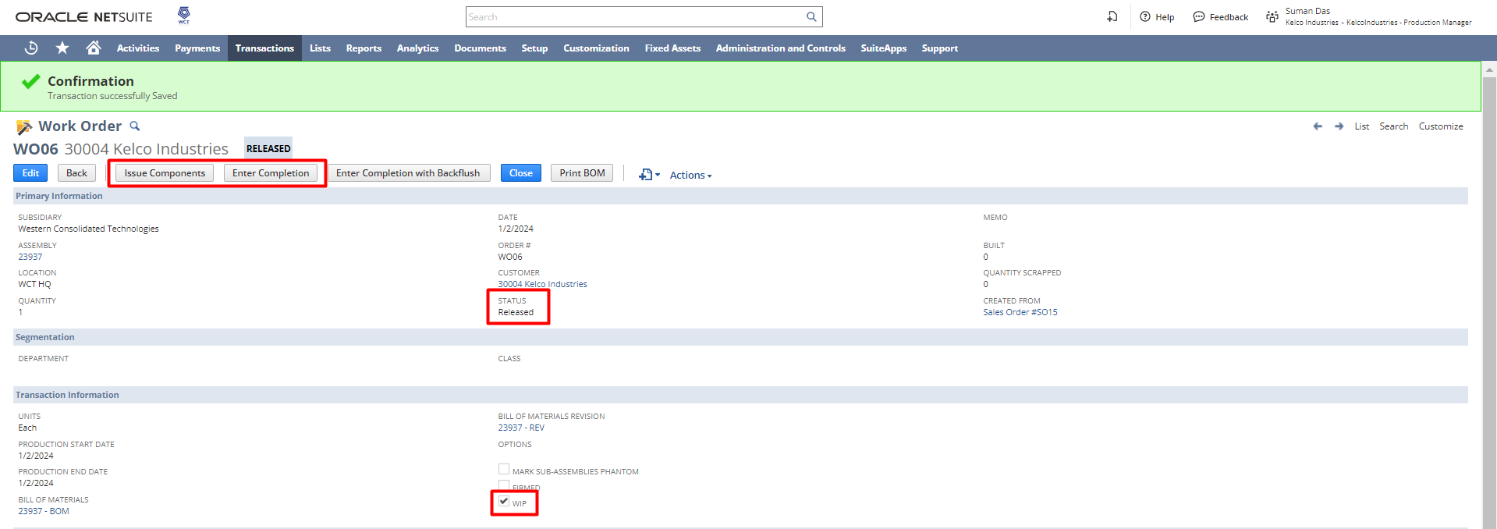
Creating Special Order from Work Order
To create a special order/purchase order click on the Spec. Ord. hyperlink which will redirect to a purchase order page and as you save that purchase order the quantity on the work order changes to the required quantity needed to facilitate the work order. This feature comes in handy in situations where the work orders require a greater quantity of a certain item that has less stock at the time of work order creation.
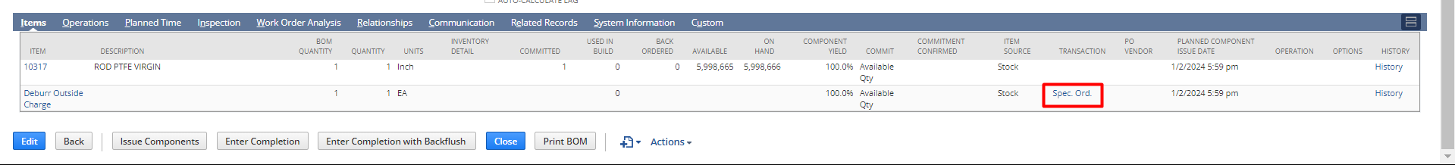
As the purchase order page opens all the details get auto populated. If required, the quantity field can be changed as per the requirement. Since we took the quantity of this item as 1 in the work order so when creating the purchase order, the system automatically takes the quantity as 1. Click Save.
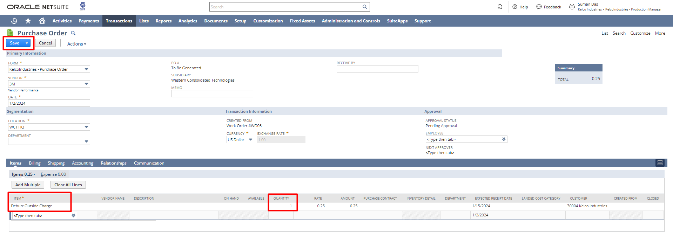

As the purchase order gets saved automatically it gets reflected in the work order item line.
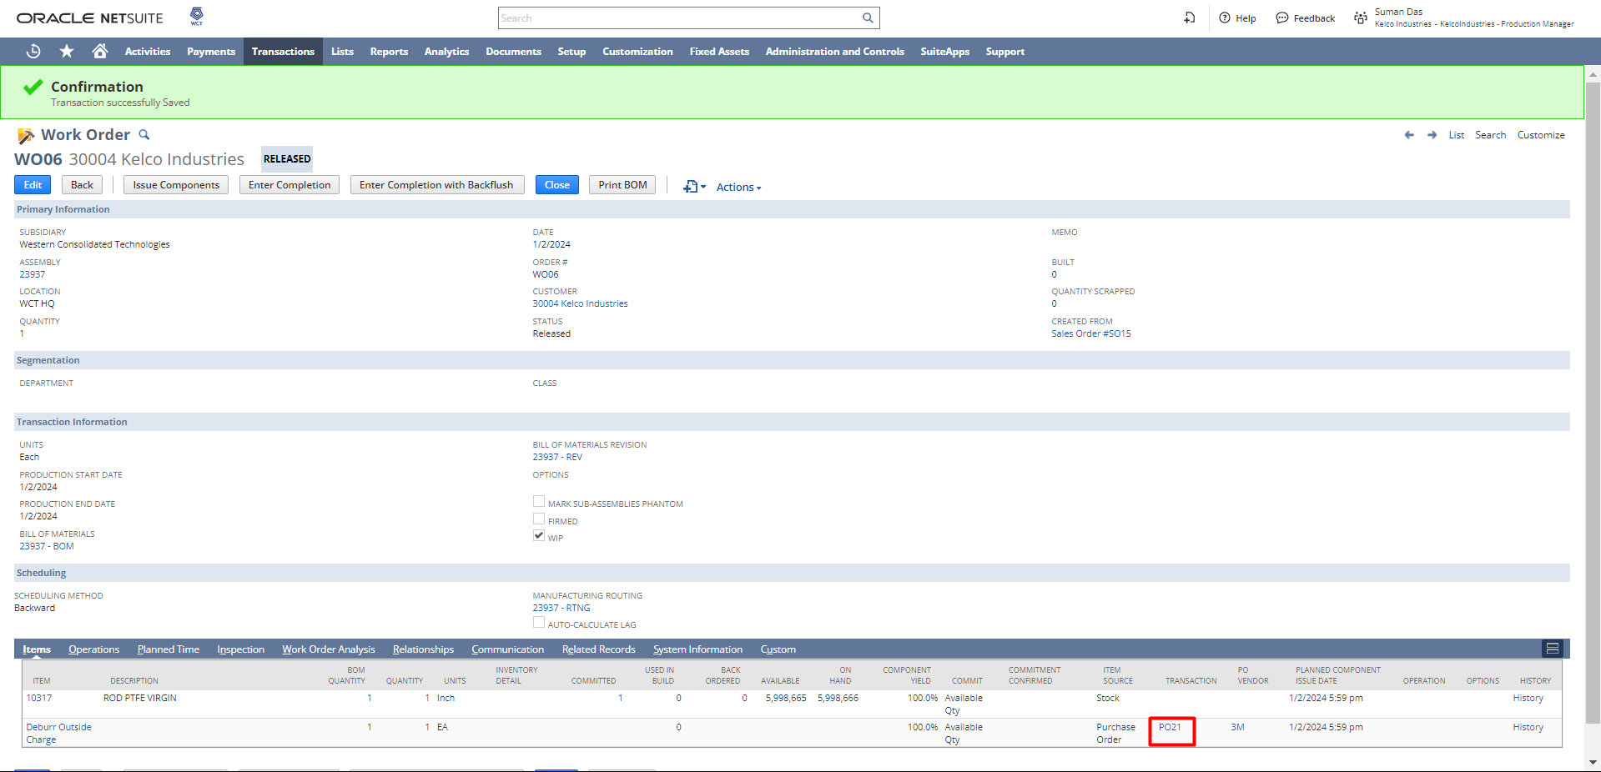

But still, the quantity is not available as we haven’t received it yet. So, to receive it click on the PO10 hyperlink.

Note: Purchasing process will be covered in detail under the P2P Demo session.

To receive the purchase order, click on the Receive button.
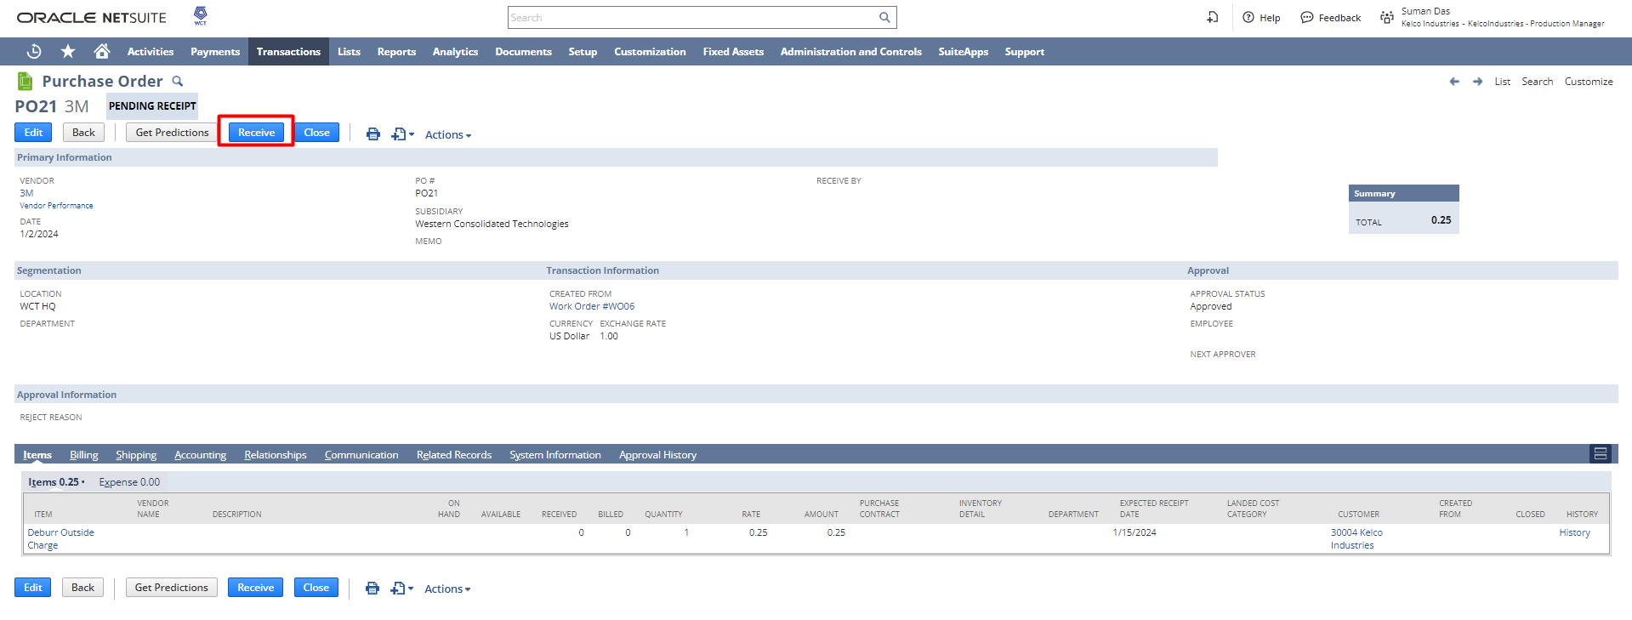

As the receive button is clicked an Item Receipt page will open. All the details will get auto populated from the purchase order. If required, the quantity field can be changed as per the items received physically.
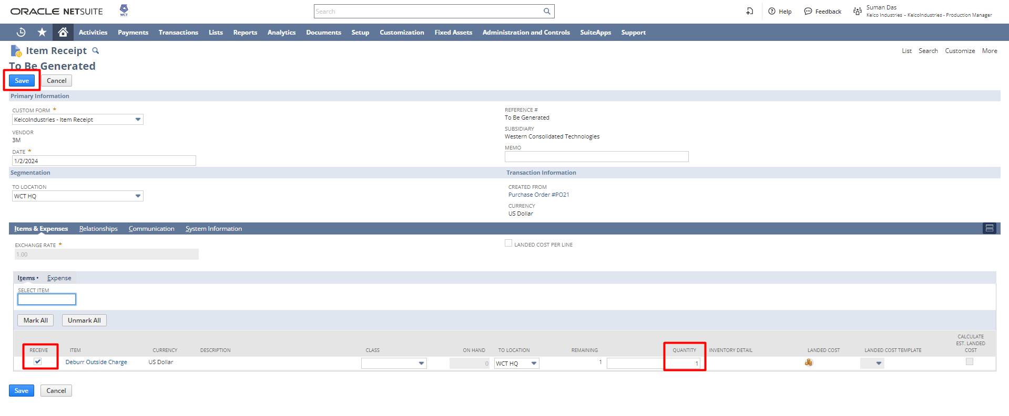

Issue Components

To start the issue components process, click on the button.
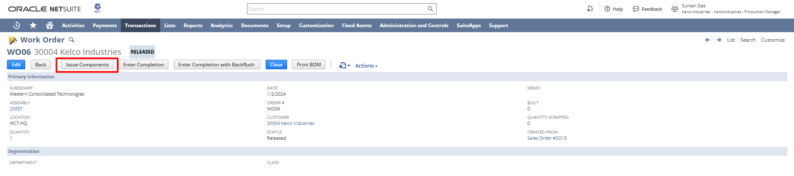

Select the Starting Operation and Ending Operation which signifies the sequence of operation. Click Save.
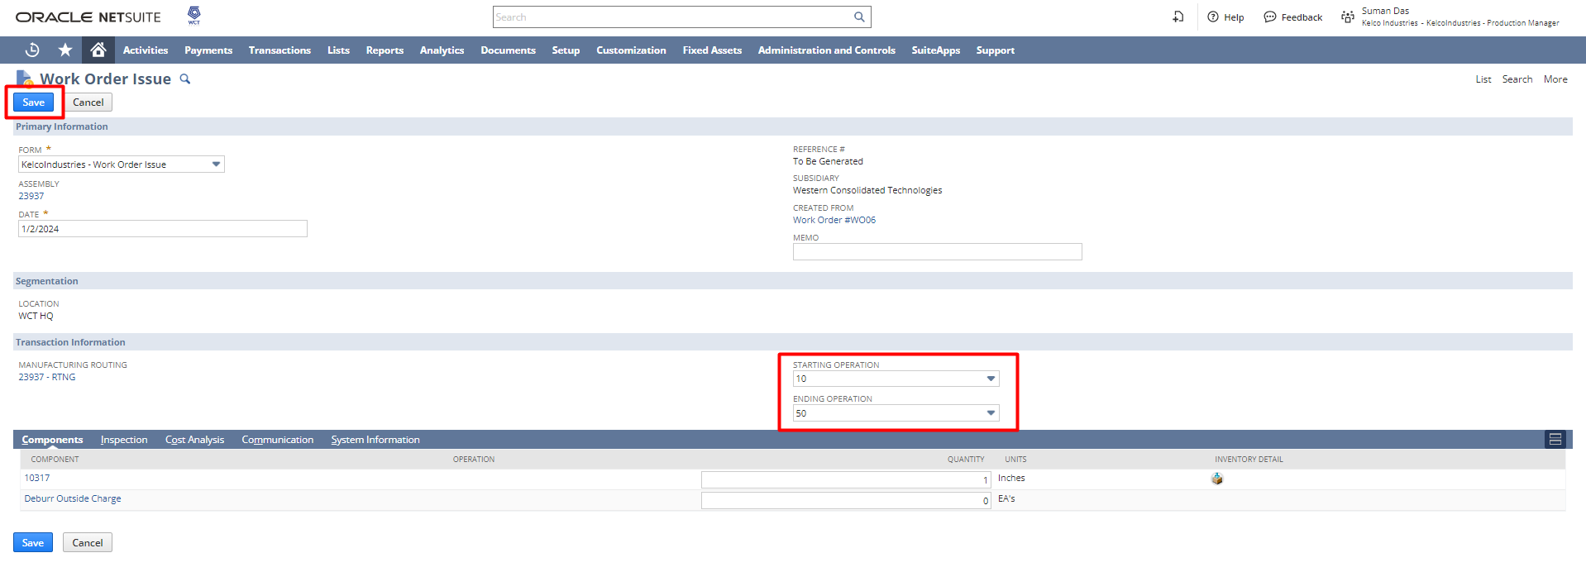

To view the GL impact of the issued components, navigate to the GL Impact subtab on the issue components page.
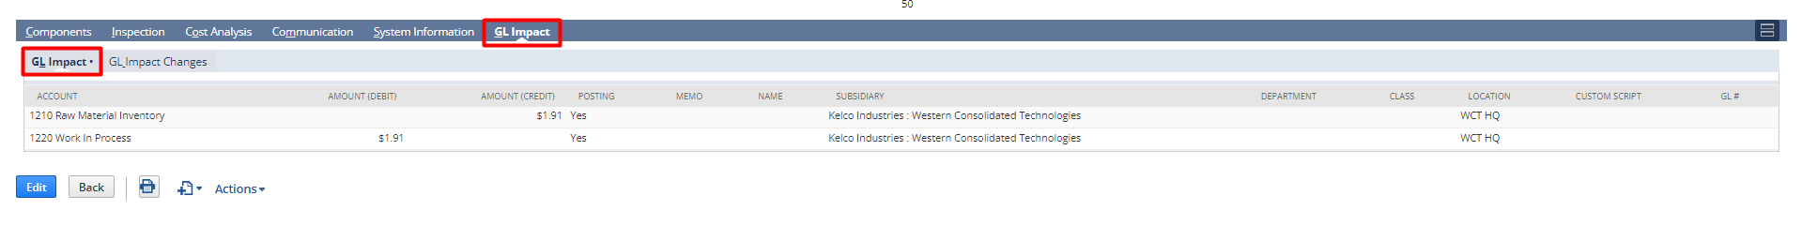

Alternatively, GL Impact can be viewed by hovering over the action option and navigating to GL Impact.
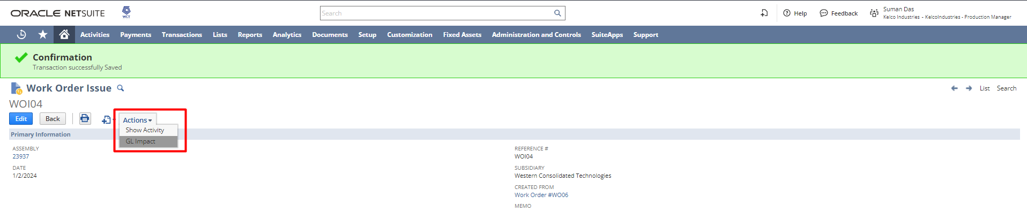

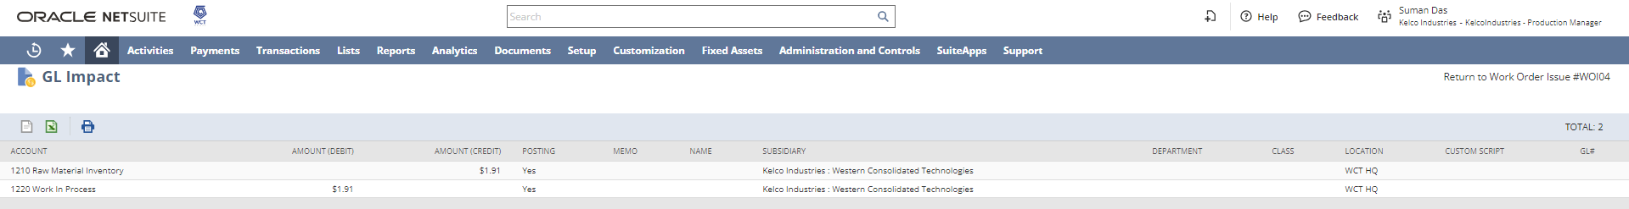

Enter Completion
To start the enter completion process, click on the button.
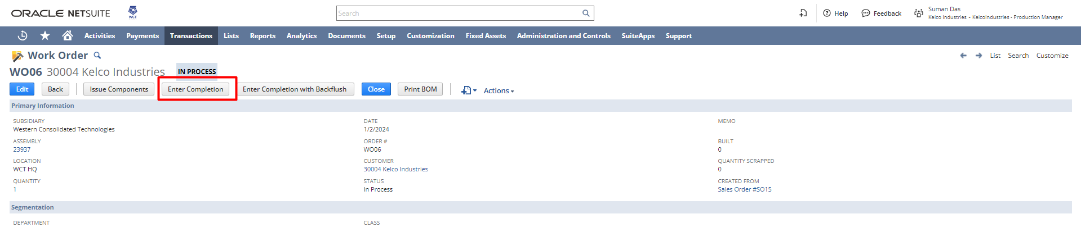
Select the Starting Operation and Ending Operation which signifies the sequence of operation. Enter the Completed Quantity. And enter the inventory details. Click Save.
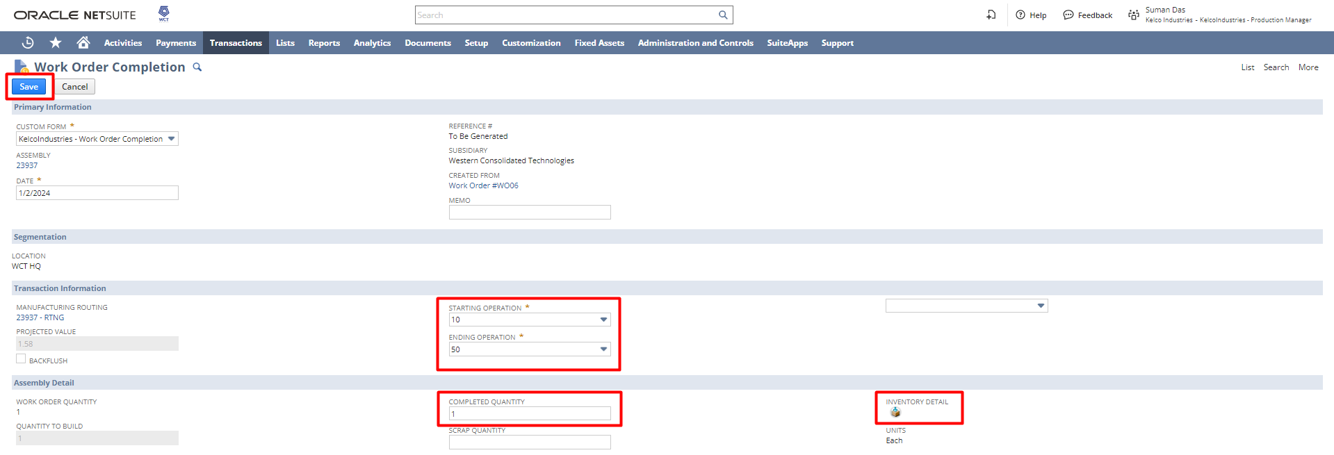
In the inventory details enter the Serial/Lot Number, BIN, and Quantity. Click Ok.
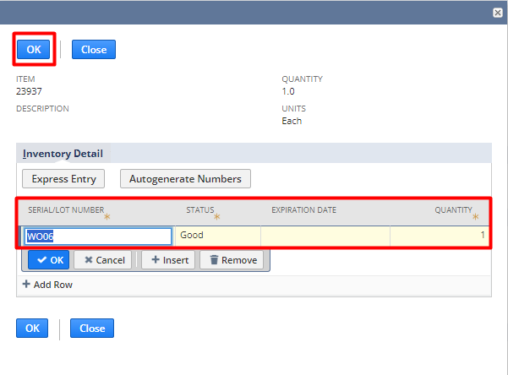
As all the details get entered the run times of different types get updated.
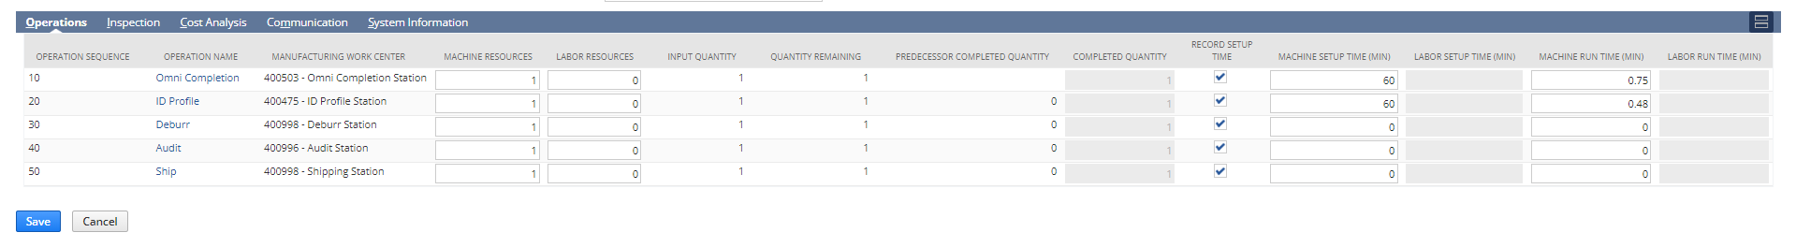
To view the GL impact of the enter completion process, navigate to the GL Impact subtab.
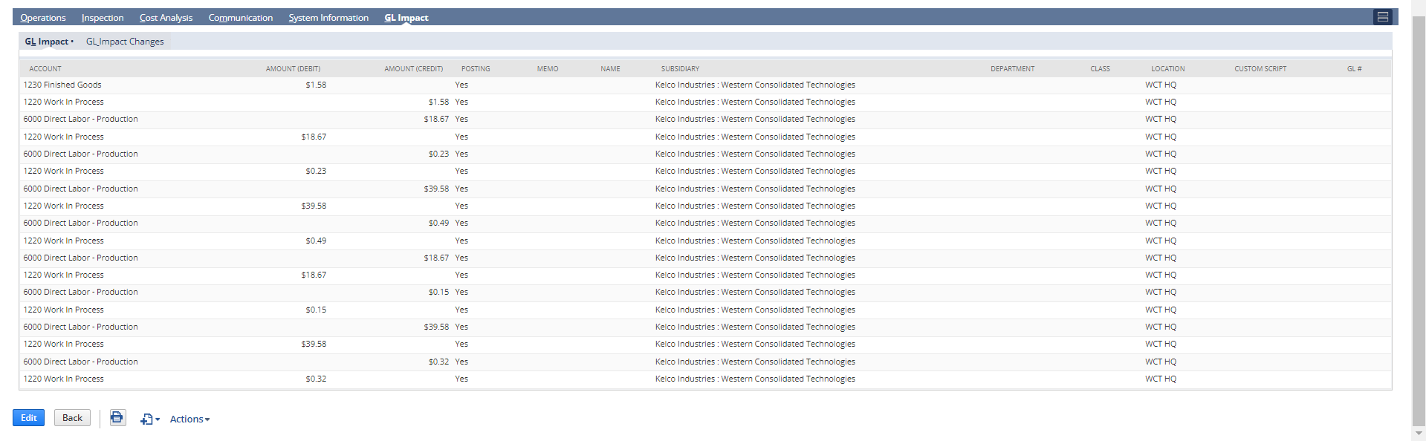

Alternatively, GL Impact can be viewed by hovering over the action option and navigating to GL Impact.
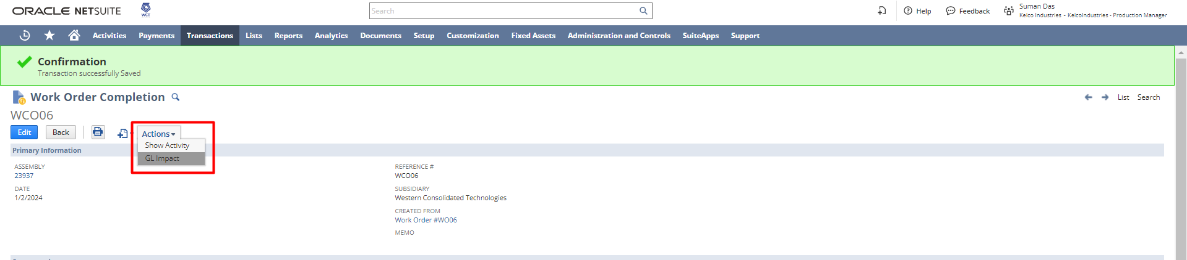

The GL Impact report can be downloaded in the form of CSV or Excel by clicking the below options
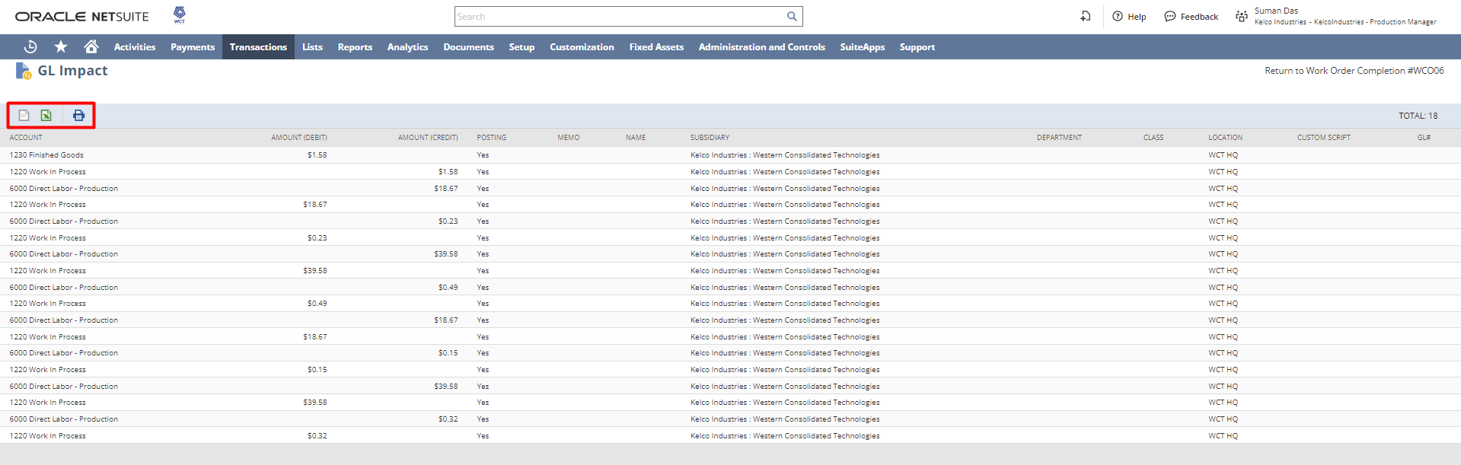

Work Order Close
Click on the Close button to close the work order. As the work order close page opens click Save.
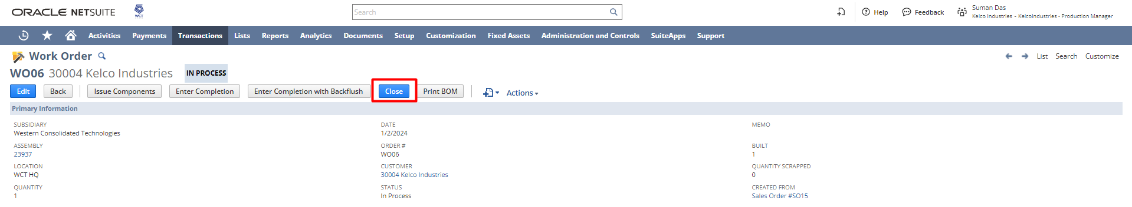

Manufacturing Operation Task
Through this, all the operations which have been created for different work orders can be viewed.
Navigation: Transactions → Manufacturing → Manufacturing Operation Tasks
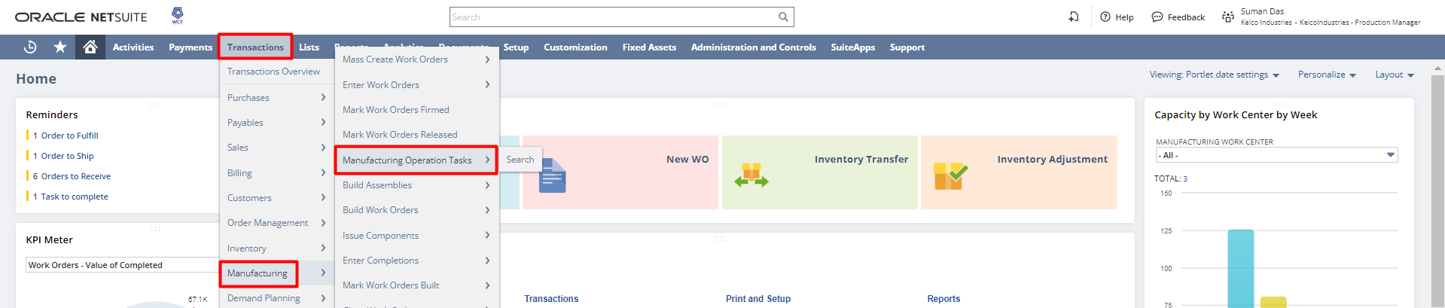
By using the filters, the operations can be viewed and under which location it is performed.
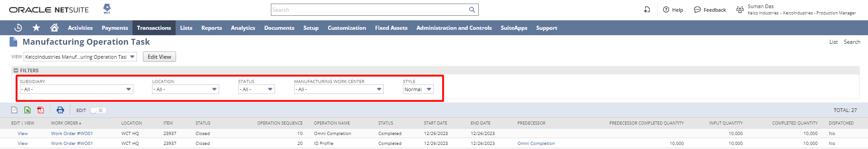
Print Manufacturing Traveler Ticket
Navigation: Transaction → Manufacturing → Print Manufacturing Traveler
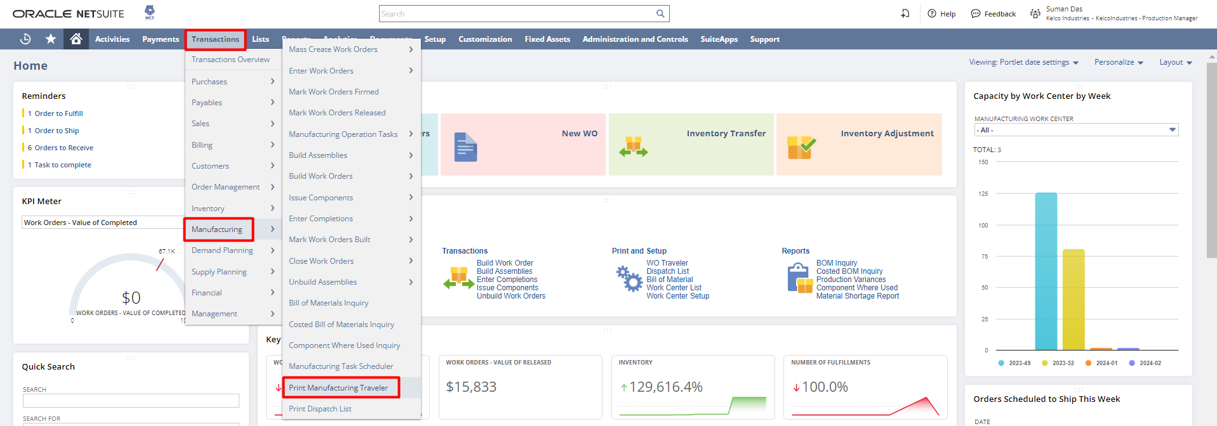

Toggle the dates as per the requirements and check the Checkbox of the work order required to proceed. Click Print.
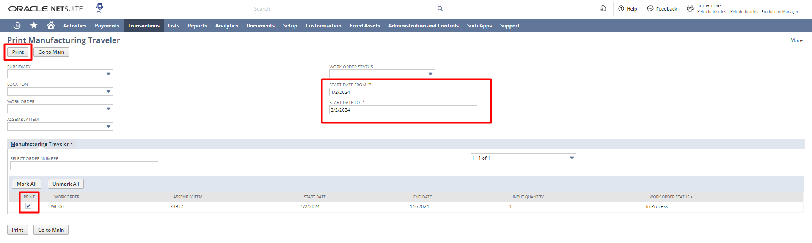

As the print button is clicked a confirmation ribbon appears with a hyperlink Here. Click on the Here hyperlink.
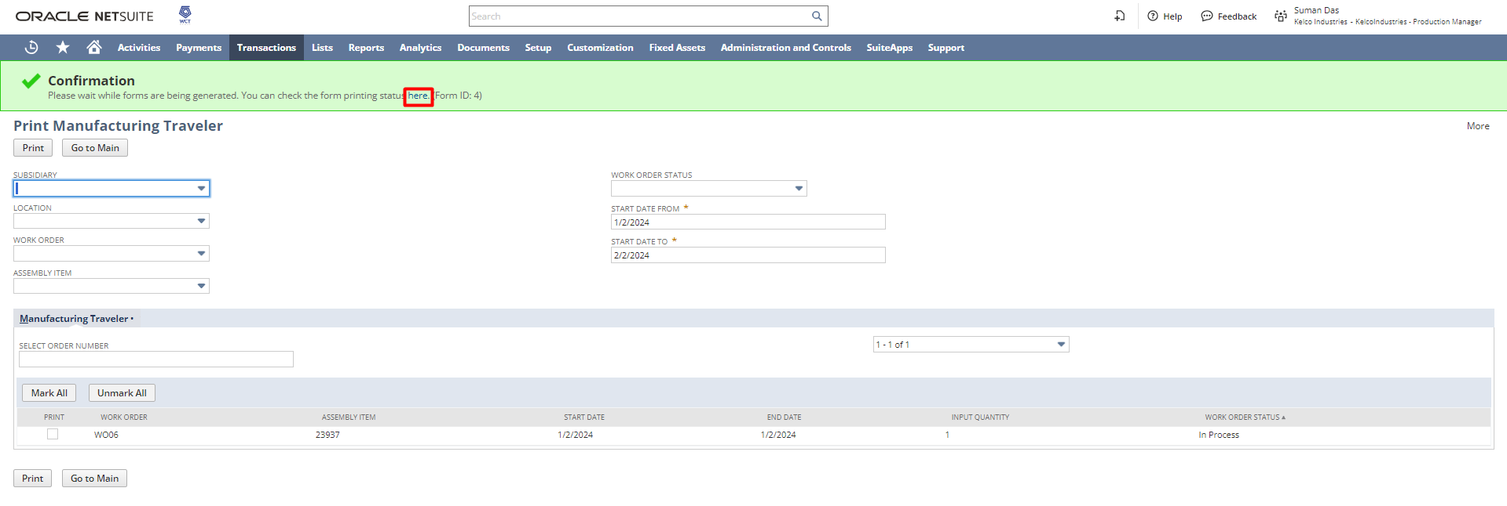

As the here hyperlink is clicked a form print page status page will open. Click on the View hyperlink to view the traveler ticket.
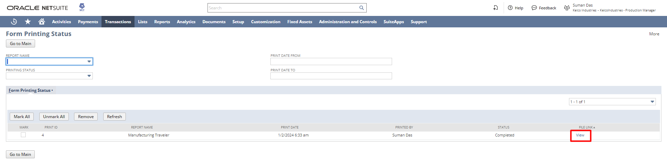

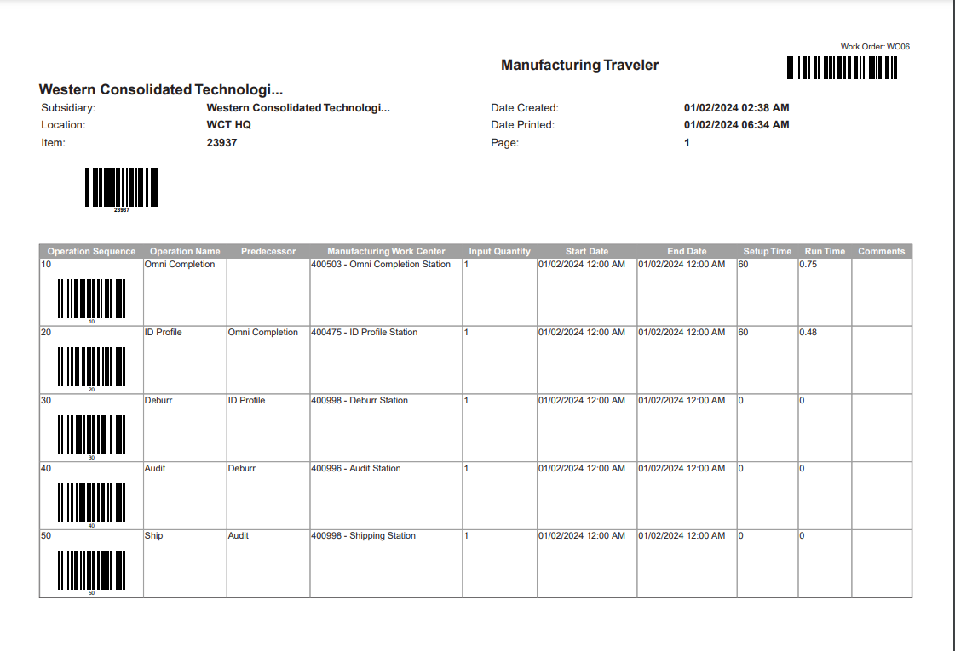
Complete till this
Manufacturing Task Scheduler
Through this, all the operations can be viewed with a graphical representation.
Navigation: Transactions → Manufacturing → Manufacturing Tasks Scheduler
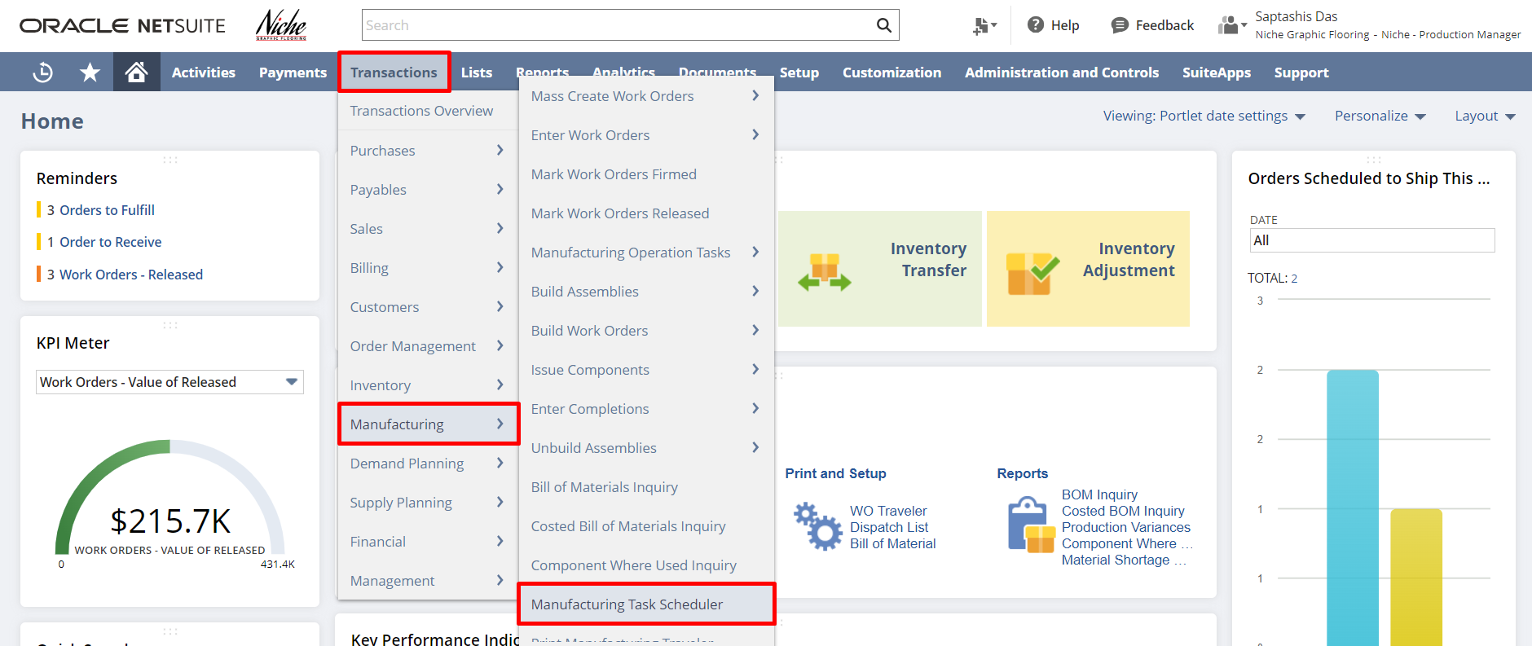
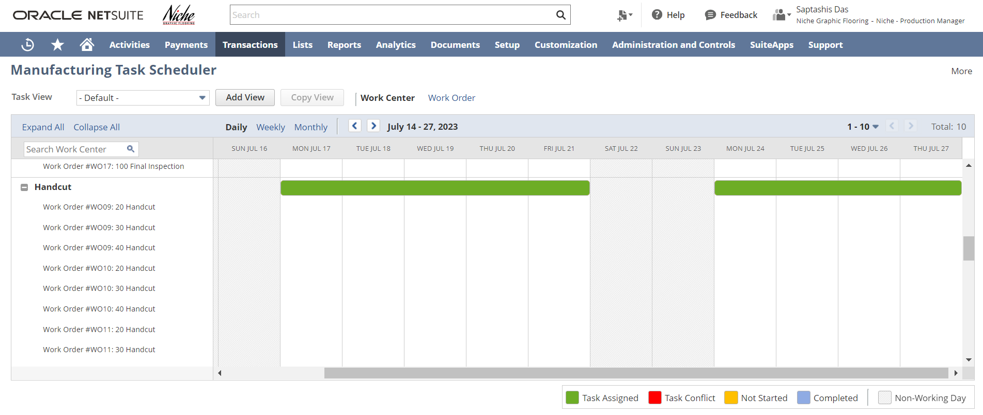

Standalone Work Order
Navigation: Transactions → Manufacturing → Enter Work Orders
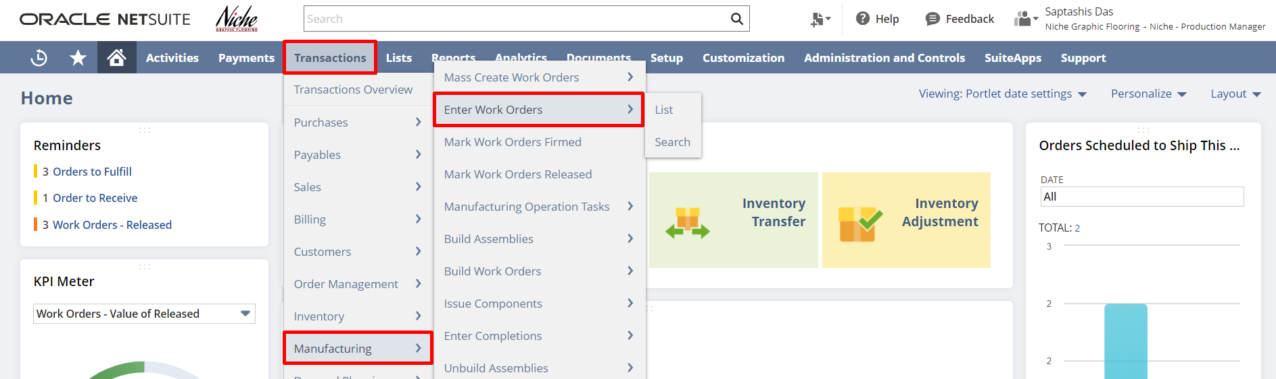
In the standalone work order select the Assembly, enter the Quantity, select the Status, Uncheck the WIP checkbox, and review the item line. Click Save.
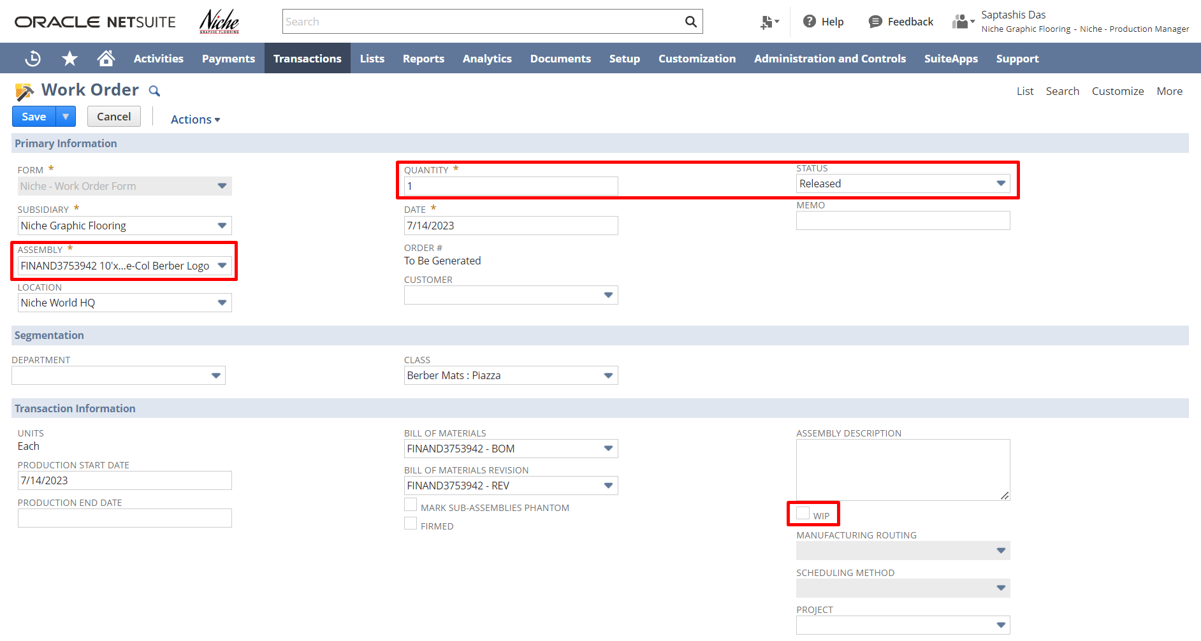
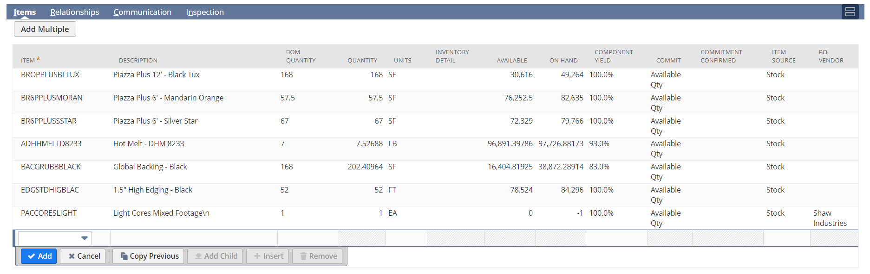

Note: In order to navigate through the assembly build section, we are not checking the WIP checkbox for the standalone work order.

Creating Assembly Build
Click on the Create Build button to start the start build process.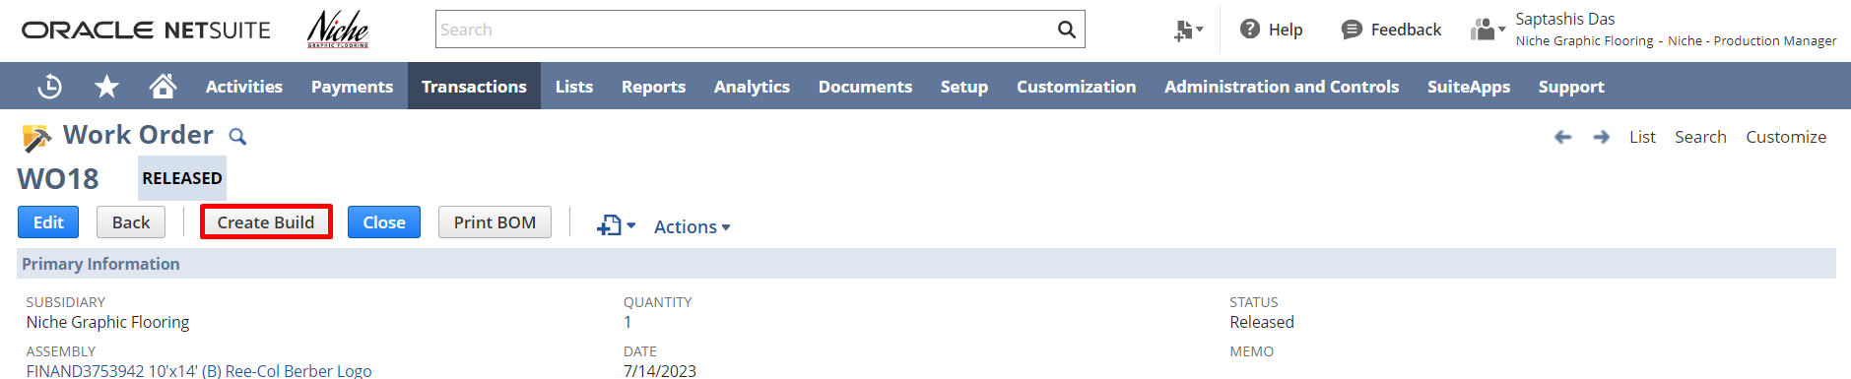
In the assembly build page enter the Quantity to Build, configure the Inventory Detail, and check the item line.
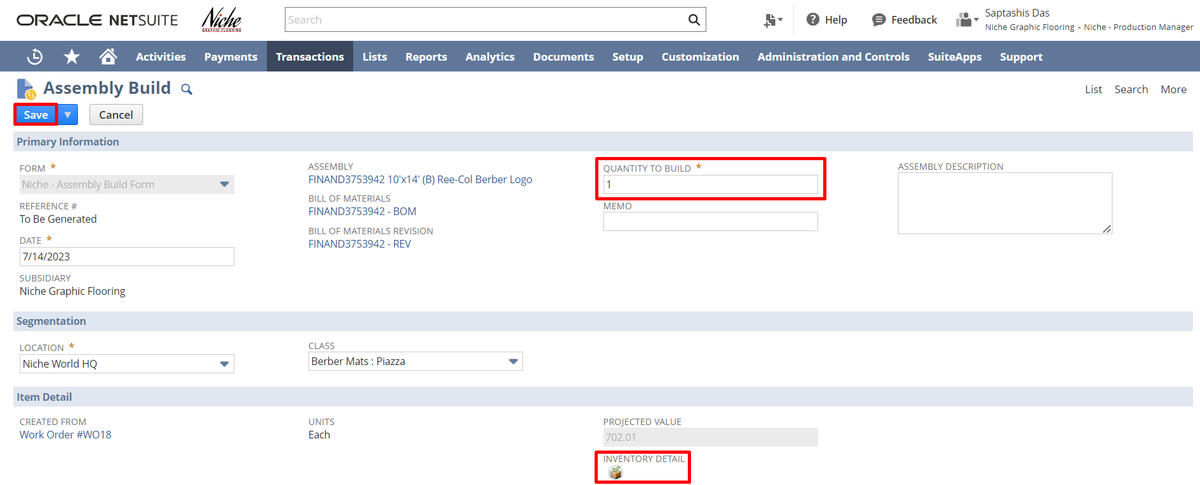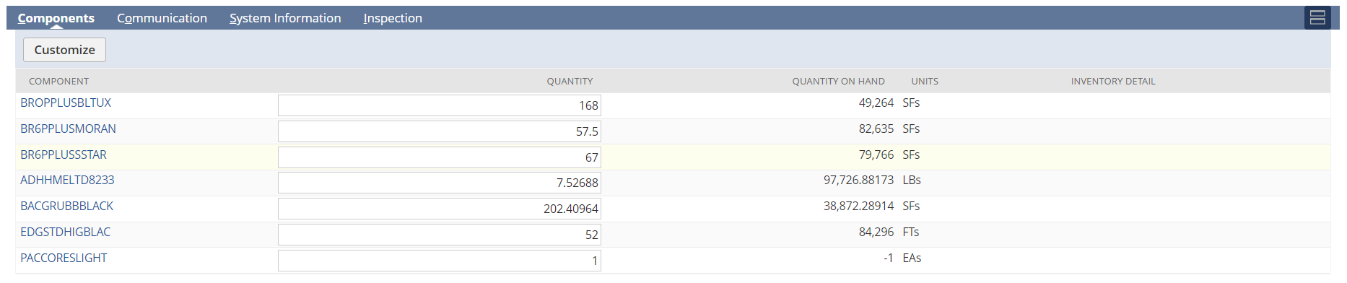

In the inventory details enter the Serial/Lot Number, BIN, and Quantity. Click Ok.
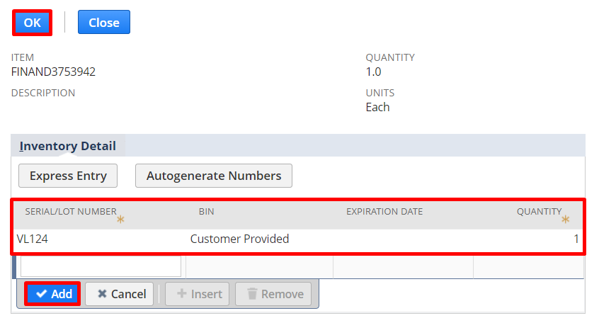

Click Save.

To unbuild any assembly build click on the Unbuild button.
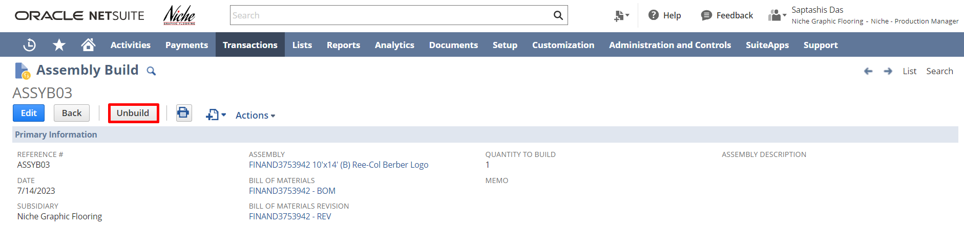

In the assembly unbuild form if need the Quantity field can be toggled and with that, the Inventory Detail option should also be toggled. Click Save.
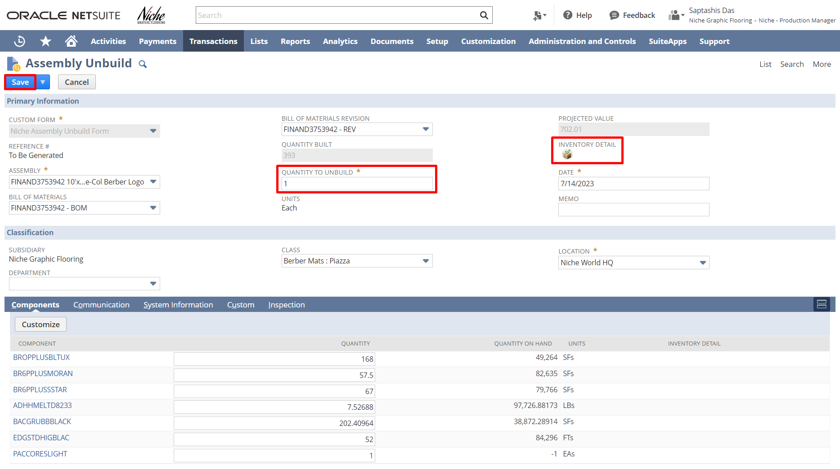

Please utilize the below feedback link for Work Orders & Assemblies, WIP & Routing module:
https://form.typeform.com/to/woCmtXub

Signature: ________________________________
Date: _____________________________________

Disclaimer:
Upon signing off on the process flow document, you are confirming that the process has been set up per the SOW within NetSuite per your business's needs. Any changes or modifications requested after sign-off will need to be a "change request" at an additional fee.

*** PLEASE ensure that you have logged into NetSuite and tested the process prior to signing off on the setup. Paapri requires sign-off on this document prior to moving forward with any additional design meetings.

